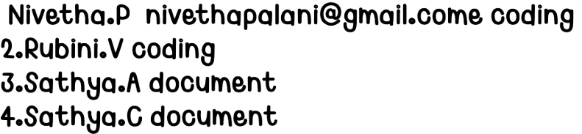

NAAN MUDHALVAN PROJECT

**Cook Book-Your Virtual Kitchen Assistant**

1 Introduction

Project Title: Cook Book

Team id:NM2025TMID48351

Team leader Name:Nivetha.P

Mail id:nivethapalani497@gmail.com

Team Members:

1

2. Project Overview

Purpose:   
SmartCook is a React.js-based online cookbook application that allows users to browse,   
save, and share recipes. It aims to make cooking easier by providing detailed recipes,   
step-by-step instructions, and personalized recommendations.

Features:

- Browse recipes by category, cuisine, or ingredients  
- Save favorite recipes to personal profile  
- Add and edit user-submitted recipes  
- Responsive UI for mobile and desktop

2

**3. Architecture**

Component Structure:  
- Header (navigation bar)  
- RecipeList (list of recipes)  
- RecipeDetail (individual recipe page)  
- Favorites (user’s saved recipes)  
- AddRecipeForm (form to add new recipes)

- Footer

State Management:   
Using React Context API to manage global state for recipes and user favorites.

Routing:   
React Router v6 handles navigation between Home, Recipe Detail, Favorites, and Add Recipe

pages.

**4. Setup Instructions**

Prerequisites:

– Node.js

– MongoDB

– Git

– React.js

– Express.js – Mongoose – Visual Studio Code

Installation Steps

1.​Clone the Repository

**5. Folder Structure**

Client:

/src  
 /components  
 Header.js  
 RecipeList.js  
 RecipeDetail.js  
 AddRecipeForm.js

3

/pages  
 Home.js  
 Favorites.js  
 /context  
 RecipesContext.js  
 /assets  
 images/

Utilities:

- api.js for fetching recipes from API  
- helpers.js for common formatting functions

**6. Running the Application**

Frontend:cd client

npm start

Backend:cd server npm start

Access:http://localhost:3000

**7. Component Documentation**

Key Components:  
- RecipeList: Displays recipe cards fetched from API. Props: recipes[].  
- RecipeDetail: Shows full recipe details. Props: recipeId.

Reusable Components:  
- RecipeCard – used in RecipeList and Favorites.

- Button – styled button component used throughout the app.

**8. State Management**

Global State:

Managed by RecipesContext for recipes, favorites, and user login status.

Local State:

Form input states managed inside AddRecipeForm.

**9. User Interface**

Include screenshots or GIFs of:

- Home page showing recipes  
- Recipe detail page  
- Adding a recipe

4

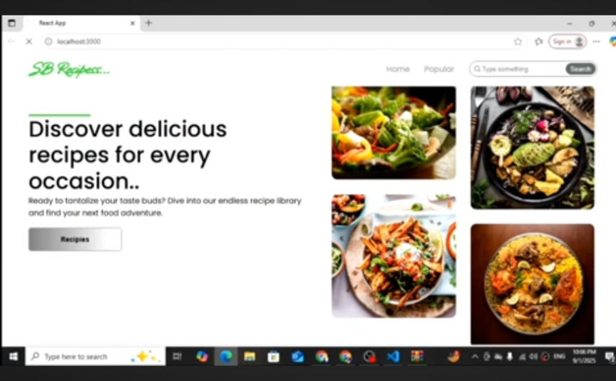

**10. Styling**

CSS Frameworks/Libraries:

Tailwind CSS for styling; Styled Components for scoped styles.

Theming:

Dark and light mode toggle implemented via context.

**11. Testing**

Testing Strategy:

Jest + React Testing Library for unit and integration tests.

Code Coverage:

Using jest --coverage to ensure 80%+ coverage.

**12. Screenshots or Demo**

Add actual screenshots or a demo link:

- Demo Link: https://smartcook-demo.netlify.app

5

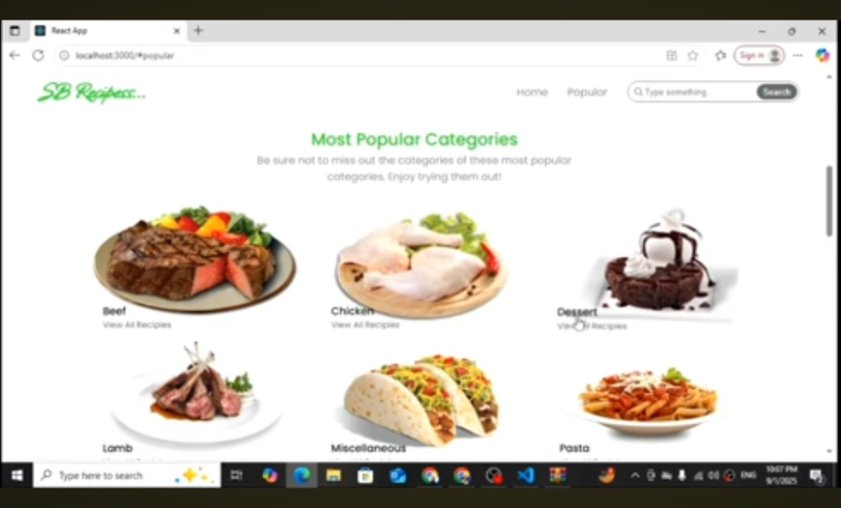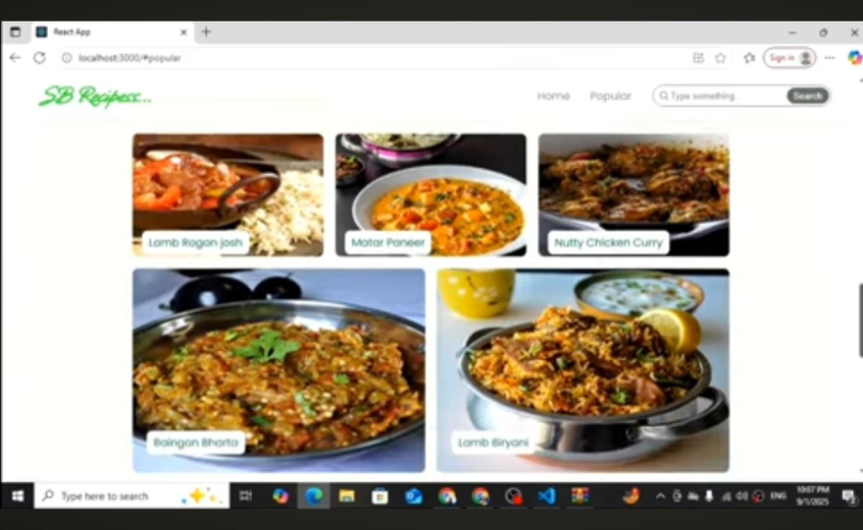

**13. Known Issues**

Search filtering may be slow with very large recipe lists.

Image upload sometimes fails on slow networks.

6

**14. Future Enhancements**

Add shopping list generation from recipe ingredients

Introduce push notifications for new recipes

Offline mode for saved recipes

7